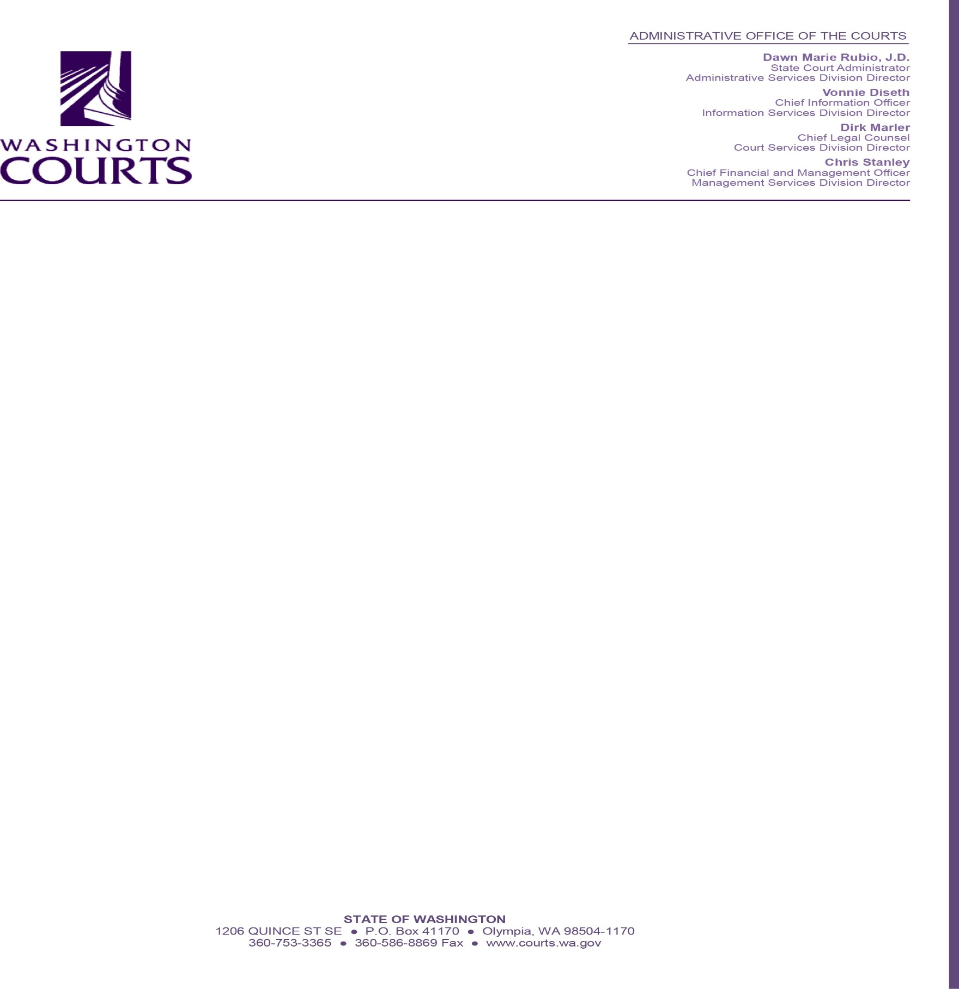

September 19, 2022

TO: ___________________(Name, Title)
FROM: ___________________(Name, Project Manager)
RE: Letter of Agreement for Lived Experience Expert

This Letter of Agreement (“Agreement”) is made and entered into on the date last entered below by and between the Washington State Administrative Office of the Courts (“AOC”) and_______________,
a Lived Experience Expert, who will provide first-hand information and enhance the ability of AOC to support programs in the Washington Courts.

AOC Project Manager (“PM”) will:
- Engage the Lived Experience Expert to: participate in an interview or focus group, share their experience during an educational session, or similar activity. Specify activity here: _________________
- Complete an A19 with Lived Experience Expert’s valid tax ID number for Expert’s signature.
- Provide authorization for payment and add appropriate budget code (___________).

Lived Experience Expert will:
- Confirm interview, focus group, or education session date: ____________
- Comply with all program-related deadlines provided by AOC Project Manager.
- Provide lived experience for this program: _________________________________
- Provide valid tax identification number: ___________________________________
- Provide valid address for mailing payment: ________________________________
- Provide phone number: _______________________________________________
- Provide e-mail address if available: ______________________________________

AOC agrees to pay Lived Experience Expert the sum of $____ within thirty days of receiving the properly completed A19 invoice confirming that the interview or other activity was completed as described. A copy of this signed Agreement must accompany the invoice.

NOTE: This Agreement is a one-time agreement for a single activity. The total amount of compensation paid to Lived Experience Expert cannot exceed $600 in a calendar year regardless of the number of activities.

Administrative Office of the Courts |  | Lived Experience Expert
Signature Date |  | Signature Date
Name |  | Name
Title |  | Title

